**Safety Report**

1. Safety report should be filled out by the Safety Officer.
2. No Cummunications are required.
3. Phase should include (Commissioning or Construction).
4. Status should include (Open or Closed).
5. accident date should be (Manual). Report date & Report Time will take the date & time of report submission
6. Rename description of accident to details of accident.
7. Injury severity (Low, Medium, High)
8. Injury Type to include:

* Physical
* Biological

1. Injured Body Part to include:

* Hands
* Arm
* Leg & Knee
* Feet
* Back/Waist
* Head/Neck
* Chest

1. Causes:

* Falling Objects
* Equipment Related Accidents
* Fires and Explosions
* Trench or Building Collapses
* Heat Stroke
* Overexertion
* Respiratory Diseases
* Ventilation

1. Remove Reference field
2. Remove Accident Time field
3. Beside Temp but C & F drop down option
4. Rename Precipitation field to Humidity (%)
5. Draft & Submit options are use instead of Submit

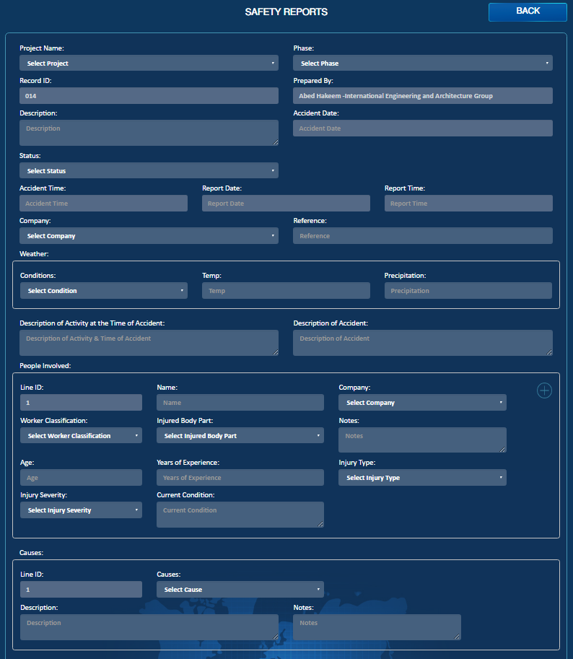

Email

PDF

Details of the accident

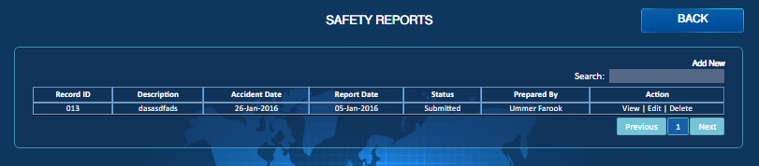

Transmittal Letter

Email

PDF